**Picture puzzle game**

Introduction:

The game deals with rearranging a jumbled parts picture to their original place to complete the picture.

**Description:**

In this game the user can select a picture from his gallery which gets divided into square blocks. One of the block is removed and other blocks are randomly jumbled, some of the blocks will also be rotated. The player has to get the blocks into their right position through the space provided by the removed block.

Fog: While playing the game, the users view of the blocks will be partially or fully blocked by a randomly appearing fog. As the difficulty of the game increases the fog appearance rate will also increase.

**Activities:**

Activity1:-

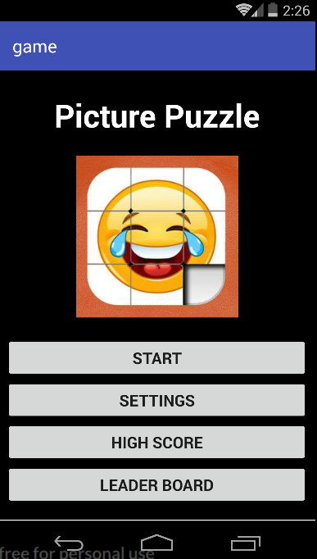

Main page of the game. This activity acts as the portal to other activities. This page contains the title of the game, start button to start the game, and following elements:

* Start button- Pressing this button will lead the user to activity2 which is pre-game settings.
* Settings button- This button will redirect the users to settings menu where the user can adjust volume settings and default settings.
* High Score - This contains top 10 highest scores of the users.

Score calculation is done differently for different modes. For the normal mode the lowest number of moves is considered as the highest score, and for the time mode the lowest time taken to complete the game is considered to be the highest score.

* Leader board - This contains top 10 highest scores of the game, the user needs to be connected to the server in order to get these details.

Activity2:- Pre game settings.

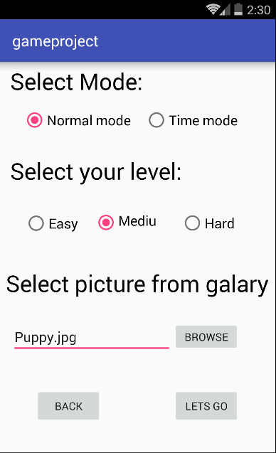

Before the game is launched, the user is directed to this page. Hear the player can Adjust various aspects of the game. They are:

* Mode
* Difficulty
* Picture

**Mode:** The Game provides two modes in which the player can play the game. They are

* ***Normal mode*:** In this mode every time the user makes a move, it is counted. The target of normal mode is finish the picture in the lowest number of moves possible.
* ***Time mode:*** In this mode the users target is to complete the picture within the given time. If there is a tie in the leader board, then it is resolved based on taking number of moves into consideration.

**Difficulty:** In this setting the user can select the difficulty of the game. The user is provided with three options.

* ***Easy:*** In easy mode the users selected picture is divided into 3X3 square grid. Every time the user positions the block in the right position, a green highlight appears around the block to indicate it. The element of fog will be as less as possible.
* ***Medium:*** In easy mode, the user selected picture is divided into 4x4 square grid. Every time the user positions the block in the right position, no green highlight appears around the block to indicate it. The element of fog will be normal.
* ***Hard:*** In this mode, the user selected picture is divided into 6x6 square grid. No indication of the correct placement of block is given. The chance of appearance of fog will be high.

**Picture:** here the user is provided a option to select a picture from their mobile gallery. If no picture is selected, the default picture provided within the game will be used.

Activity3:-

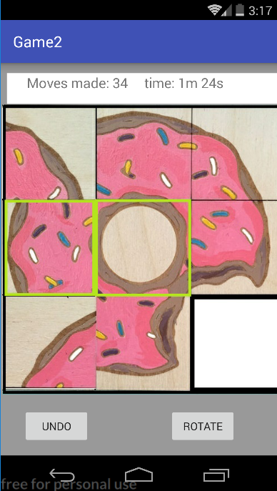

In this page the real game is loaded. The top score bare displays number of moves and time passed. The next element is a grid view of the picture with one missing block. When the player decides to move the block to its place, he/she needs to swipe the block towards the empty area of the game. Understand that this swipe can be performed only on the blocks that are above, bellow and beside the empty places. It will not work on blocks diagonally opposite to the empty space. Depending on the difficulty a fog will appear on few of the blocks covering them.

The next element is a rotate and undo buttons. When the player wishes to rotate a block, he/she needs to select the block by taping it and the click on the rotate button to rotate it 90 degrees.

Once the picture is complete the users game is over and is directed to the score page.

Activity4:-

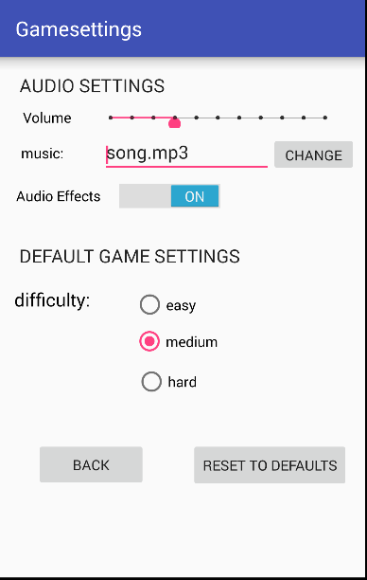

This is the settings menu. These are divided into 2 types- audio settings and default game settings.

* Audio settings:- This provides all the settings for volume and music. The user can select a background track of his own to play during the game. The user can completely mute the audio effects that are played during the game.
* Default game settings:- Here the user can select the default difficulty of the game. This settings will be loaded everytime the user starts the game without modifying the pre-game settings.
* The user has the ability to reset all the changes made using the reset button.